AMini Project Report

On

**ARINFOCRAFT**

*Submitted in partial fulfillment of the requirements for the award of the degree of*

**BACHELOR OF** **TECHNOLOGY**

IN

**COMPUTER SCIENCE AND ENGINEERING**

**BY**

**Ms. C. PRAVALIKA (14N81A0514)**

**Ms. K. RASAGNA (14N81A0532)**

**Mr. M. ABHISHEK(14N81A0549)**

Under the guidance of

**Mr. K. PAVAN KUMAR**

**ASSISTANT PROFESSOR**

DEPARTMENT OF COMPUTER SCIENCE AND ENGINEERING



**Department of Computer Science and Engineering**

**Sphoorthy Engineering College**

**Naderagul (Vill.), Sagar Road, Near Vanasthalipuram, Balapur (Mdl.), R. R. Dist., Telangana. – 501510**

**2014-2018**

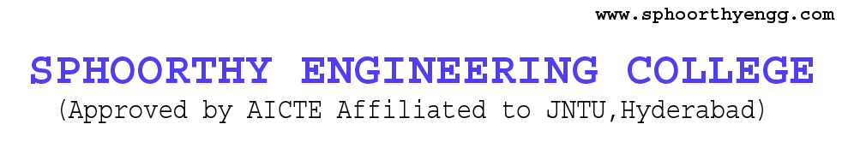

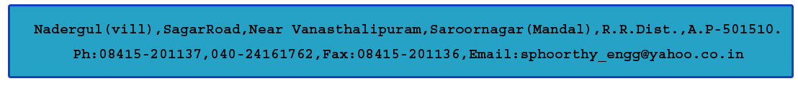

**DEPARTMENT OF COMPUTER SCIENCE AND ENGINEERING**

**CERTIFICATE**

This is to certify that project entitled “**ARINFOCRAFT”** is a bonafide work carried out by Ms. RASAGNA (14N81A0532), Ms. C. PRAVALIKA (14N81A0514), Mr. M. ABHISHEK (14N81A0549), in partial fulfillment for the award of Bachelor of Technology in Computer Science and Engineering, Sphoorthy Engineering College, Hyderabad during the year 2016-2017 under my supervision and guidance. The result embodied in the Project Work has not been submitted to any other University or Institute for the award of any Degree or Diploma.

**INTERNAL GUIDE HEAD OF DEPARTMENT**

**Mr. K. PAVAN KUMAR** **Mrs. J. DEEPTHI**

Assistant Professor Assistant Professor

**EXTERNAL EXAMINER**  **PRINCIPAL**

**DR. K.S. SHAJI**

**DECLARATION**

We, the undersigned, declare that the project title “**ARINFOCRAFT**” carried out at “SPHOORTHY ENGINEERING COLLEGE” is original and is being submitted to the Department of COMPUTER SCIENCE AND ENGINEERING, Sphoorthy Engineering College, Hyderabad towards partial fulfillment for the award of Bachelor of Technology.

We, declare that, the result embodied in the Project work has not been submitted to any other University or Institute for the award of any Degree or Diploma.

**Date: C. PRAVALIKA**

**Place: Hyderabad 14N81A0514**

**K. RASAGNA**

**14N81A0532**

**M. ABHISHEK**

**14N81A0549**

**ACKNOWLEDGEMENT**

The completion of this project work gives us an opportunity to convey our gratitude to all those who have helped us to reach a stage where we have the confidence to launch our career in the competitive world in the field of Computer Science.

We would like to express our heartfelt thanks to **External Guide** forpermitting us to do a project work in their esteemed organization.

We express our sincere thanks to**,** **Dr. K. S. Shaji,** Principal, Sphoorthy Engineering College for providing all necessary facilities in completing our project report.

We express our sense of gratitude to **Prof**. **Mrs.** **J. Deepthi,** Head of Department of Computer Science and Engineering, who encouraged us to select the project and completion of this project with providing necessary facilities.

Our honest thankfulness **to** **Mr. K. PAVAN KUMAR**, (Internal Guide) for his kind help and for giving us the necessary guidance and valuable suggestions in completing this project work and in preparing this report.

We take the opportunity to express our gratitude to the Management, Teaching and Non-Teaching Staff of Sphoorthy Engineering College for their kind co-operation during the period of our Study.

Finally, we would like to thank our parents & friends for their continuous encouragement and support during the entire course of this project work.

**BATCH 2014 - 2018 C. PRAVALIKA(14N81A0514)**

**K. RASAGNA(14N81A0532)**

**M. ABHISHEK(14N81A0549)**

**ABSTRACT**

“ArInfoCraft” is all about the displaying the information whether scanned product that are scanned by our app is safer or harmful for a diabetic person. Using this app, we can help all the diabetic people by letting them use the right product which is safer for their health and also by suggesting them some of them.

**CONTENTS**

|  |  |  |
| --- | --- | --- |
| **SNO.** | **PATICULARS** | **PAGE NO.** |
| **1** | **INTRODUCTION** | **1** |
| **2** | **LITERATURE SURVEY** | **2** |
| **3** | **SYSTEM ANALYSIS**  EXISTING SYSTEM  PROPOSED SYSTEM  SYSTEM REQUIREMENTS | **4**  4  4  5 |
| **4** | **REQUIREMENT ANALYSIS**  FEASIBILITY STUDY  OPERATIONAL FEASIBILITY  ECONOMICAL FEASIBILITY  SOCIAL FEASIBILITY  TECHNICAL FEASIBILITY | **6**  6  6  7  7  8 |
| **5** | **SYSTEM DESIGN**  5.1 MODULES  5.2 MODULE DESCRIPTION  5.3 SYSTEM ARCHITECTURE  5.3.1 E-R DIAGRAM  5.4 UML DIAGRAM  USE CASE DIAGRAM  CLASS DIAGRAM  SEQUENCE DIAGRAM | **9**  9  9  9  9  9  11  11  12 |
| **6** | **SOFTWARE MODEL**  MODEL USED TO DEVELOP THE PROJECT | **13**  13 |
| **7** | **IMPLEMENTATION**  7.1 INSTALLATION OF SOFTWARES  7.2 CREATION OF UNITY APPLICATION  7.3 TRANSFORMING UNITY TO ANDROID APP  7.4 CREATION OF WEB PAGES  7.5 DEPLOYING OF WEB PAGES | **14**  14  15  30  33  33 |
| **8** | **SAMPLE CODE**  8.1 CODE FOR WEB PAGES  8.2 CODE FOR UNITY APPLICATION | **36**  36  41 |
| **9** | **OUTPUT SCREEN** | **42** |
| **10** | **SYSTEM TESTING**  10.1 INTRODUCTION  10.2 TESTING METHODOLOGIES  10.2.1 UNIT TESTIING  10.2.2 INTEGRATION TESTING  10.2.3 FUNCTIONAL TESTING  10.2.3.1 FUNCTIONAL TESTING  10.2.3.2 SYSTEM TESTING  10.2.4 BLACK BOX TESTING  10.2.5 WHITE BOX TESTING  10.2.6 LEVELS OF TESTING  10.2.7 TYPES OF TESTING  10.2.8 TEST CASE DOCUMENTATION  10.2.9 TEST CASES | **44**  44  44  44  45  45  45  45  46  46  47  47  48  49 |
| **11** | **CONCLUSION AND FURTHER ENCHANCEMENTS**  11.1 CONCLUSION  11.2 FURTHER WORK | **51**  51  51 |
| **12** | **ONLINE REFERENCES** | **52** |

**1.INTRODUCTION**

Diabetes is the major disease which is getting effected to the large number of people irrespective of their ages. Persons who are suffering from this disease should consume less sugar.

A Diabetic before purchasing the food products such as biscuits, cakes, fruit juices, etc. he observes the sugar percent present in that particular product. It might be difficult for him to identify the sugar percentage because the information given might confuse the person to consume it or not. Though we have the barcodes the information doesn’t convey the user whether to consume that product or not. Whereas, it just displays the available sugar content.

In favor to diabetics we developed an android application which displays whether to consume the particular product or not. This is implemented just by scanning the image of the product where you can find the complete details about the product and also whether it is safe to consume or not.

In this project we use a Unity Engine to develop an android application which is simplistic and useful.

**2.LITERATURE SURVEY**

According to the IDF, the [number of diabetics](https://www.diabetes.co.uk/diabetes-prevalence.html) in the world stands at 365 million people, representing around 8.5% of the global population. Today, there are 11 million Canadians living with diabetes or pre-diabetes

Most of the food we eat is turned into glucose, or sugar, for our bodies to use for energy. The pancreas, an organ that lies near the stomach, makes a hormone called insulin to help glucose get into the cells of our bodies.

When you have diabetes, your body either doesn't make enough [insulin](https://www.diabetes.co.uk/about-insulin.html) or can't use its own insulin as well as it should. This causes sugars to build up in the blood.

Diabetes can cause serious health complications including heart disease, blindness, foot problems, heart attack, stroke, anxiety, nerve damage, and erectile dysfunction (men), kidney failure, and lower-extremity amputations.

Diabetes-related complications can be very serious and even life-threatening. Properly managing blood sugar levels reduces the risk of developing these complications.

TYPES OF DIABETES:

Type 1 diabetes occurs when the immune system mistakenly attacks and kills the cells of the pancreas. Type 1 diabetes is always treated with insulin. Meal planning also helps with keeping blood sugar at the right levels.

Type 2 diabetes occurs when the body can’t properly use the insulin that is released (called insulin insensitivity) or does not make enough insulin. As aresult, sugar builds up in the blood instead of being used as energy. About 90 per cent of people with diabetes have type 2 diabetes. Type 2 diabetes more often develops in adults, but children can be affected.

A third type of diabetes, gestational diabetes, is a temporary condition that occurs during pregnancy. It affects approximately two to four per cent of all pregnancies

The main concern within the process designing the application is the access towards the different types of the information among various products but there is no application where they refine that information for sake of the diabetes. Hence we intended to refine the data present   for the general products that we buy in our date to date life and refine the information such that the product can be judged according to the basis of sugar levels so that the diabetes patients can but better product for protection of their health rather than searching the contents and confusing whether to buy a product or not. This can be done easily by just scanning the required product.

**CONCLUSION:** This project is to make a diabetic patient to scan a product and the tell whether the product is good enough for him or not.

### 3.SYSTEM ANALYSIS

The basic idea of “ArInfoCraft” is to let the diabetic patient to know whether to buy a product or not. This is useful majorly to the diabetic patients as they can enjoy their products with low content of the sugar and be protected against the higher ones.

This is also useful to the normal people who intended to be in diet and wanted to have lower sugar content in the products they buy. This might not improve the health of the person but still suggests a person about the harmful ones and let them keep in a safe side and take care of the person’s health.

Moreover, the real meaning of our title “ArInfoCraft” means

AR- Augmented Reality

Info – Information

Craft- Crafting

Hence we intended to craft(develop) the information about the general products and help the diabetes people to get better products where we used AR(and also web) to do so.

**3.1 EXISTING SYSTEM:**

There are few websites which displays the contents of the products. This is useful up to some extent but, majority of the people can’t decide whether to purchase that product or not. Thus these sites acts as the data part only.

**3.2 PROPOSED SYSTEM:**

In this project, we intended to scan the product which is in the Augmented Reality. This can relive us from the software for producing and maintaining the pictures and identifying the right one. Here we use the web platform to give access of information to the people easily and to everyone who has the internet.

Thus the app can help people to access the product (only One after the another) whereas the website can provide the lump of information where user has to find the product information he needs. **ADVANTAGES OF PROPOSED SYSTEM:**

It takes less time for the user to get the details of the product as we don’t have any intermediate software sitting in the app we develop. Having the global access of information via maintaining a website for it.

**3.3 SOFTWARE REQUIREMENTS:**

|  |  |
| --- | --- |
| OPERATING SYSTEM | * Windows 7,8,10, 64bit version only * Mac OSX 10.9+ * Windows XP and vista are not supported |
| RAM REQUIRED | 4GB Recommended(500MB for IDE+1.5 GB for Android SDK and emulator system image) and also to Unity Engine |
| SOFTWARES USED | * Unity 2017.3 or 5.6 * Vuforia SDK * XAMPP OR WAMP |
| ADDITIONAL REQUIREMENTS | * Java Development Kit * Android SDK Tool(if testing on an android device) * VISUAL STUDIOS |

**4. REQUIREMENT ANALYSIS**

Requirement analysis is the process of determining user expectations for a new or modified product. This specifies the quantifiable, relevant and detailed. It explains about feasibilities, and also software and hardware requirements.

**4.1 FEASIBILITY STUDY:**

An analysis and evaluation of a proposed project to determine following feasibility regarding Technical, economical, operational feasibilities as follows

Preliminary investigation examines project feasibility the likelihood the system will be useful to the organization. The feasibility of the project is analyzed in this phase with a very general plan for the project and some cost estimates. During system analysis the feasibility study of the proposed system is to be carried out. For feasibility analysis, some understanding of the major requirements for the system is essential.

The main objective of the feasibility study is to test the Operational, Economical and Social feasibility for adding new modules and debugging old running system. All systems are feasible if they are unlimited resources and infinite time.

● Operational Feasibility

● Economic Feasibility

● Social Feasibility

**4.1.1 OPERATIONAL FEASIBILITY:**

Operational feasibility is dependent on human resources available for the project and involves projecting whether the system will be used if it is developed and implemented. It is a measure of how well a proposed system solves the problems, and takes advantage of the opportunities identified during scope definition and how it satisfies the requirements identified in the requirements analysis phase of system development. This reviews the willingness of the organization to support the system.

The essential questions that help in testing the operational feasibility of a system include the following:

● Does current mode of operation provide cost-effective services to the end user?

● Does current mode of operation make maximum use of available resources, including Natural resources?

● Does current mode of operation provide reliable services?

● Are the services flexible and expandable?

● Government regulations

● Will the proposed system really benefit the End User?

● Does the overall Utility Increase?

● Will accessibility or Control will be lost?

● How do the end-users feel about the new system?

**4.1.2 ECONOMIC FEASIBILITY**

Economic analysis could also be referred to as cost/benefit analysis. It is the most frequently used method for evaluating the effectiveness of a new system. In economic analysis, the procedure is to determine the benefits that are expected from a candidate system and compare them with costs. If benefits outweigh costs, then the decision is made to design and implement the system.

Possible questions raised in economic analysis are:

● Is the system cost effective?

● Do benefits outweigh costs?

● The cost of doing full system study.

● Estimated cost of hardware.

● Estimated cost of software/software development.

The concerned business must be able to see the value of the investment it is pondering before committing to an entire system study. If short-term costs are not overshadowed by long-term gains or produce no immediate reduction in operating costs, then the system is not economically feasible, and the project should not proceed any further. If the expected benefits equal or exceed costs, the system can be judged to be economically feasible. Economic analysis is used for evaluating the effectiveness of the proposed system. This will review the expected costs to see if they are in-line with the projected budget or if the project has an acceptable return on investment. At this point, the projected costs will only be a rough estimate. It is only required to determine if it is feasible that the project costs will fall within the target budget or return on investment. A rough estimate of the project schedule is required to determine if it would be feasible to complete the systems project within a required timeframe. The required timeframe would need to be set by the organization

.

**4.1.3 SOCIAL FEASIBILITY**

Social feasibility addresses the influences that a proposed project may have on the social system in the project environment. The ambient social structure may be such that certain categories of workers may be in short supply or non-existent. The effect of the Project on the social status of the project participants must be assessed to ensure compatibility. It should be recognized that workers in certain industries may have certain status symbols within the society.

The aspect of study is to check the level of acceptance of the system by the user. This includes the process of training the user to use the system efficiently. The user must not feel threatened by the system, instead must accept it as a necessity. The level of acceptance by the users solely depends on the methods that are employed to educate the user about the system and to make him familiar with it. User’s level of confidence must be raised so that he is able to make some constructive criticism, which is welcomed, as he is the final user of the system.

**4.1.4 TECHNICAL FEASIBILITY:**

This details how you will deliver your product or service, including issues of material and technology needed. This is based on an outline design of system requirements, to determine whether we can handle the project.

The following should be taken to consideration:

1. **Storage Compatibility** As the project goes on increasing the contents of the files such as the pictures or logos of the project and respective information is going to be gets increasing, hence we need to take care of storage analysis of the project after deployment.
2. **Maintaining unique logos**: There is no need that every team who does the project tends to keep the unique logos. There may also a need to check the uniqueness of the logos be presented for sake of proper working of the app  
   .
3. **Version Compatibility**: As the android and the platforms upgrade we need to keep track of the produced app for sake of longer working of the app.

**5. SYSTEM DESIGN**

System design is the process of defining the architecture, components, modules, interfaces, and data for a system to satisfy specified requirements. Systems design could be seen as the application of systems theory to product development.

**5.1 MODULUS**

Augmented Reality Module

**5.2 MODULUS DESCRIPTIONS**

This Module Displays whether user should consume a product or not

**5.3 SYSTEM ARCHITECUTURE**

**5.3.1 ER DIAGRAMS**

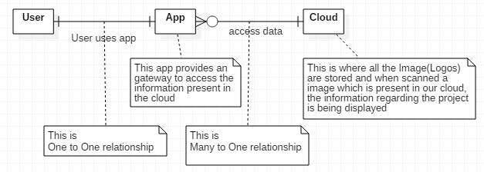

Fig 5.3.1 ER Diagram

**5.4 UML DIAGRAM**

The Unified Modeling Language allows the software engineer to express an analysis model using the modeling notation that is governed by a set of syntactic semantic and pragmatic rules.

The UML represents a collection of best engineering practices that have proven successful in the modeling of large and complex systems. The UML is a very important part of developing objects oriented software and the software development process. UML uses mostly graphical notations to express the design of software projects.

A UML system is represented using five different views that describe the system from distinctly different perspective. Each view is defined by a set of diagram, which is as follows.

**1. User Model View**

* 1. This view represents the system from the user perspective.
  2. The analysis representation describes a usage scenario from the end-users perspective.

**2. Structural model view**

* 1. In this model the data and functionality are arrived from inside the system.
  2. This model view models the static structures.

**3. Model View**

It represents the dynamic of behavioral as parts of the system, depicting the interactions of collection between various structural elements described in the user model and structural model view.

**4. Implementation Model View**

In this the structural and behavioral as parts of the system are represented as they are to be built.

**5. Environmental Model View**

In this the structural and behavioral aspects of the environment in which the system is to be implemented are represented.

UML is specifically constructed through two different domains they are:

* + UML Analysis modeling, this focuses on the user model and structural model views of the system.
  + UML design modeling, which focuses on the behavioral modeling, implementation modeling and environmental model views.

Use case Diagrams represent the functionality of the system from a user’s point of view. Use cases are used during requirements elicitation and analysis to represent the functionality of the system. Use cases focus on the behavior of the system from external point of view.

Actors are external entities that interact with the system. Examples of actors include users like administrator, customer, Railway Authority, Travel Agent …etc., or another system like central database.

**5.4.1 USE CASE DIAGRAM**

A use case diagram is a graphic depiction of the interactions among the elements of a system. A use case is a methodology used in system analysis to identify, clarify, and organize system requirements.

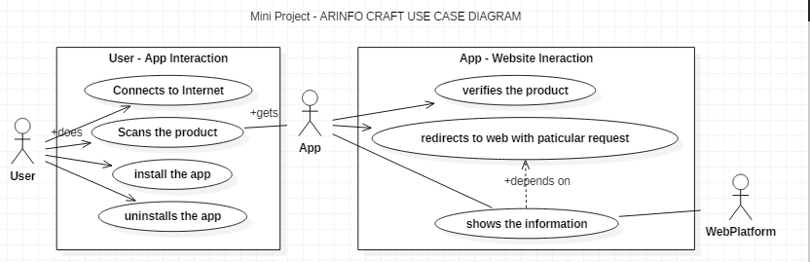

**5.4.2 CLASS DIAGRAM**

Class Diagram provides an overview of the target system by describing the objects and classes inside the system and the relationships between them. It provides a wide variety of usages; from modeling the domain-specific data structure to detailed design of the target system. With the share model facilities, you can reuse your class model in the interaction diagram for modeling the detailed design of the dynamic behavior.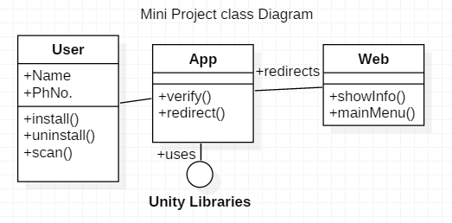

**5.4.3 SEQUENCE DIAGRAM**

 Represents object collaboration and is used to define event sequences between objects for a certain outcome and how the object is sending message in one-way or multiple or self .and it shows at what particular time you are using the object.

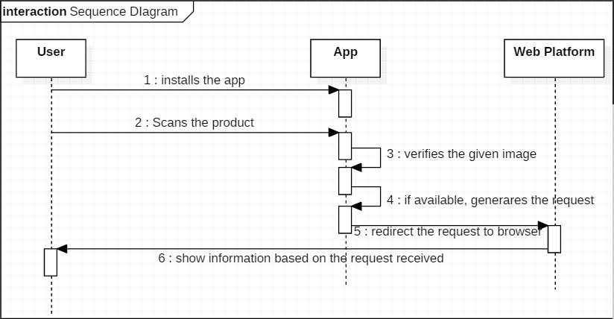

**6 SOFTWARE PROCESS MODEL**

A software process (also known as software methodology) is a set of related activities that leads to the production of the software. These activities may involve the development of the software from the scratch, or, modifying an existing system.

Any software process must include the following four activities:

* Software specification (or requirements engineering): Define the main functionalities of the software and the constrains around them.
* Software design and implementation: The software is to be designed and programmed.
* Software verification and validation: The software must conform to its specification and meets the customer needs.
* Software evolution (software maintenance): The software is being modified to meet customer and market requirements changes.

Model We used to develop the model is “PROTOTYPE” Model where the Client interaction interface is being develop as soon as the interface can help the user with all the requirement he need and be pleasant and fast enough to deploy and use them. If any changes be made after deploying we again come back to the development stage and get started with new prototype.

**7.IMPLEMENTATION**

The most crucial phase of any project is the implementation. This includes all those activities that take place to convert from the old system to the new system. It involves setting up of the system for use by the concerned end user. A successful implementation involves a high level of interaction between the analyst, programmers and the end users. The most common method of implementation is the phased approach, which involves installation of the system concurrently with the existing system. This has its advantage in that the normal activity carried out, as part of the existing system is any way hampered. The end users are provided with sufficient documentation and adequate training in the form of demonstration/presentation in order to familiarize with the system.

**7.1 DESCRIPTION**

The process of putting a decision or plan into effect and executing the plan, which describes the overview of the project, what are the languages are used, tags gives brief description regarding the project.

**7.1 INSTALLATION OF SOFTWARES.**

1. XAMPP
2. UNITY
3. Vuforia (just download zip file and import that into unity editor)

**7.2: CREATION OF UNITY APPLICATION:**

1)Vuforia Configuaration:

Go to the vuforia’s official website(from the link in the References) and sign in  
or sign up if you do not have the previous account in Vuforia.  
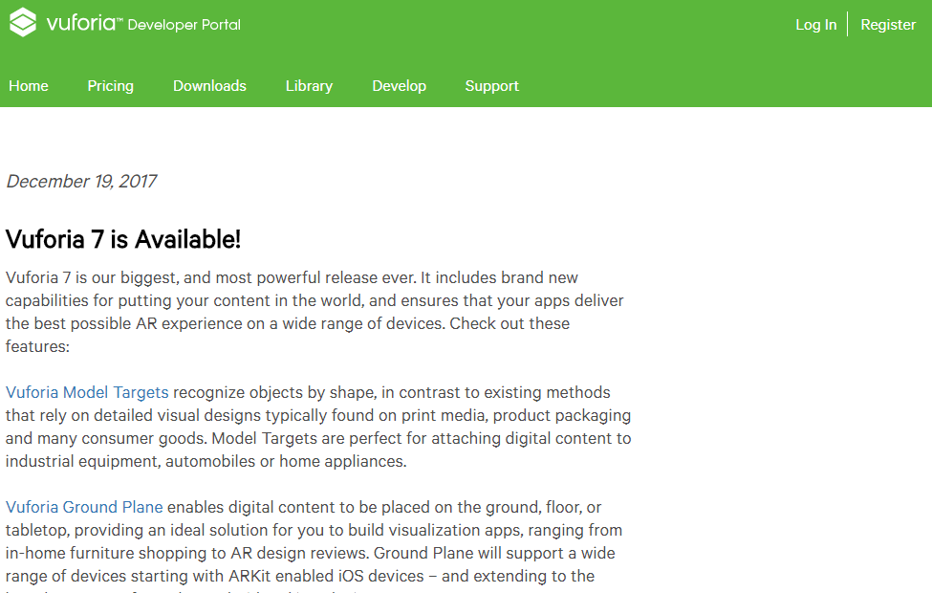

Fig 7.2.1 welcome screen of the Vuforia   
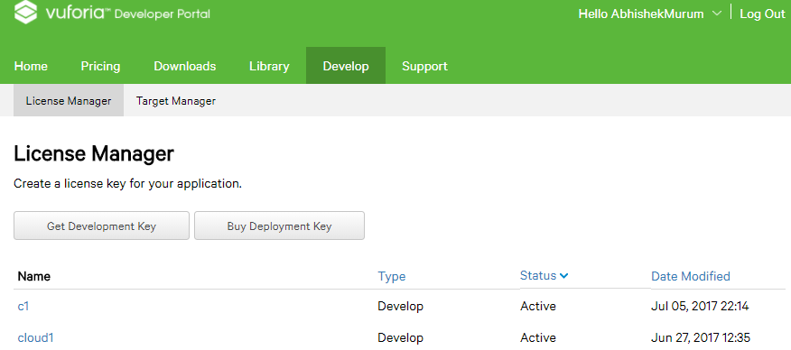  
Fig 7.2.2 Adding License Manager  
Press on the ‘Get Development Key’ and fill the corresponding details.  
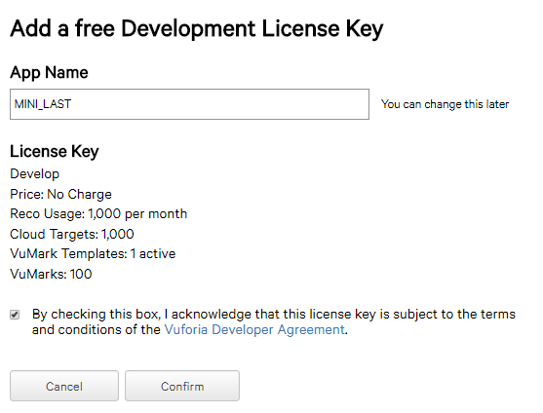

Fig 7.2.3 Obtaining License Manager and click on confirm  
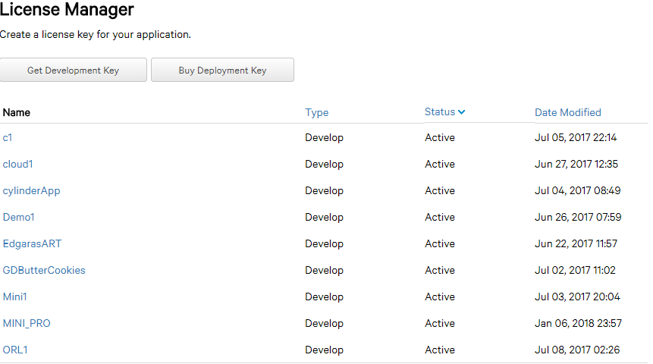

Fig 7.2.4 Successfully obtained License

this shows us the lists of application keys made by us.Hence click on our key ‘MINI_PRO’ which shows the License  
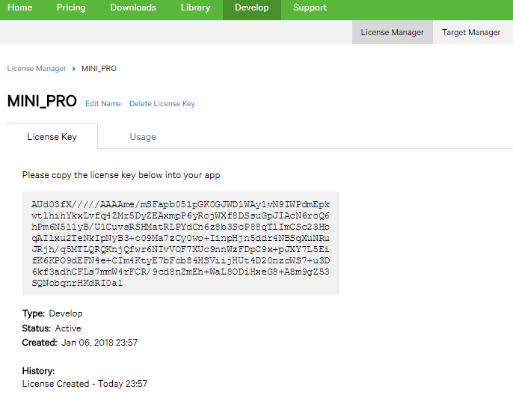

Fig 7.2.5 True Key is shown in above figure. Then move to the ‘Target Manager’ tab.  
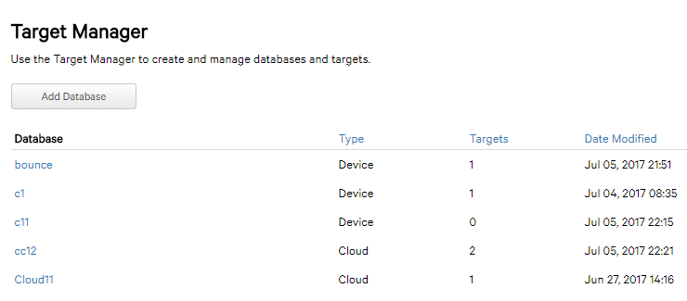

Fig 7.2.6.1 Creating new Target Manager

To create new target click on ‘Add Database’. Then fill the appropriates and click on ‘create’.  
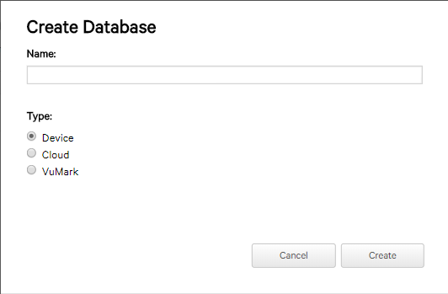 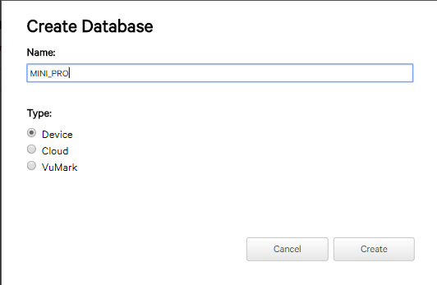

Fig 7.2.6.2 Creating new Target Manager. Click on ‘MINI_PRO” to have ImageTargets as option  
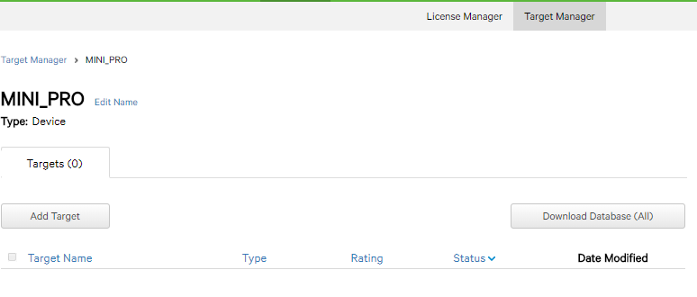  
Fig 7.2.6.3 shows completion of ImageTarget Database.

where ‘Add Target’ lets to add our own image as Target. Click on ‘Add Target’   
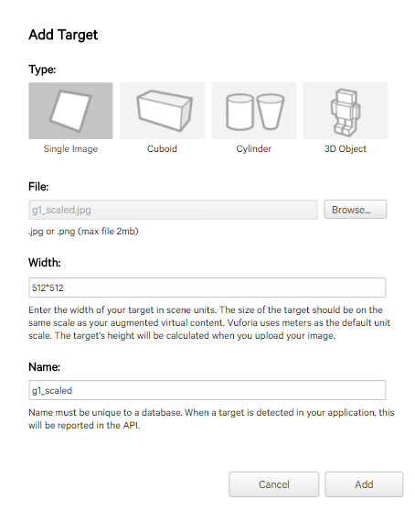

Fig 7.2.7.1 Adding Contents to database  
After filling the appropriates click on ‘Add’.This will upload the target into cloud.  
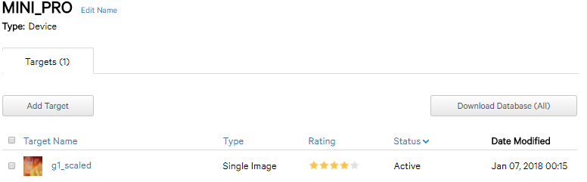  
Fig 7.2.7.2 Adding Contents to database.

Hence we see our target image.  
Now Click on ‘Download Database’ to obtain the Unity package of respective Image Target.

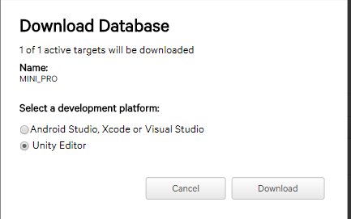

Fig 7.2.8.1 Downloading Database. Click on ‘Download’.  
  
Fig 7.2.8.2 Downloading Database. Click on ‘Download’. click on ‘Save’  
  
Fig 7.2.8.3 Shows saved package. Click on the saved package to open in the unity editor.  
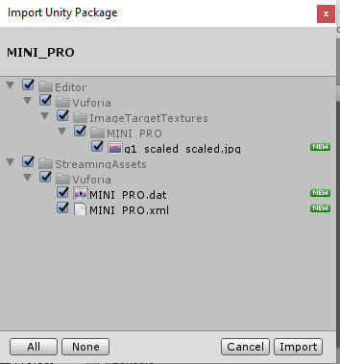

Fig 7.2.9 Showing the internal contents of downloaded package

Import Everything and click on ‘Import’. Setting a Response for the Image Target in the Unity, go to.on the right hand we can see  
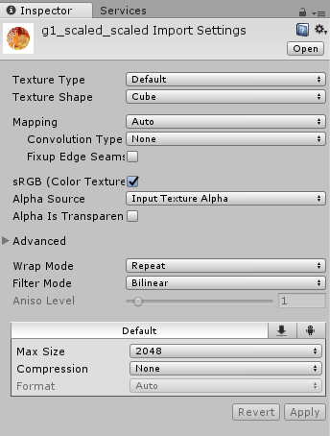  
Fig 7.2.10 Showing the Inspector View of the tool. Thus change the option ‘Cube’ as “2D” to render it as Image. Now go to Projects Tab and select the Vuforia folder Then Select the Prefabs  
  
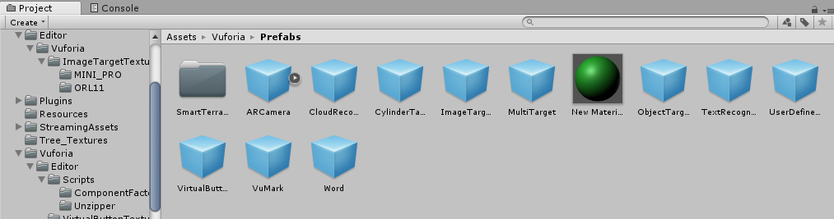

Fig 7.2.11 showing the Prefabs Contents of tool  
  
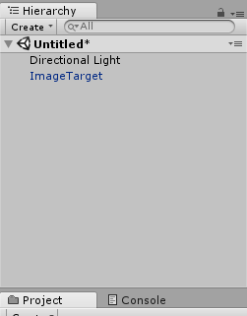

Fig 7.2.12 Drag the ‘ImageTarget’ and drop in the Hierarchy plane.Click on it to get into ‘Inspector’ tab.  
  
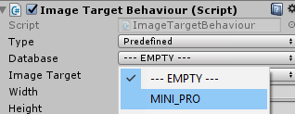

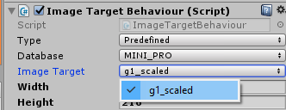

Fig 7.2.13 Set the MINI_PRO option in the Database and choose the Image Target.  
  
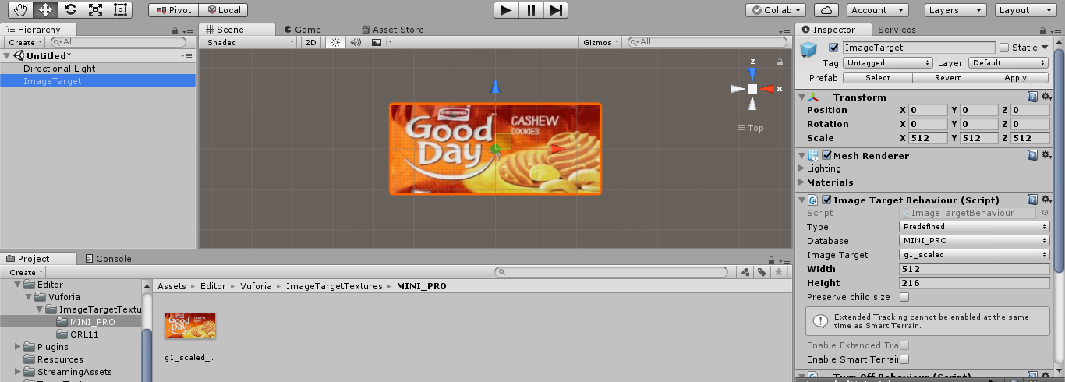

Fig 7.2.14 This displays our Image Target.  
Lets add a Virtual Button.This is done by dragging the ‘Virtual Button’ in the ‘Prefabs’ folder and dropping it on the ‘actionButton’. Renaming the button to ‘Action’.  
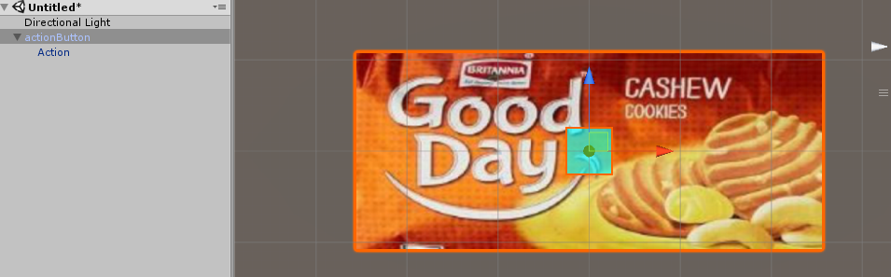  
Fig 7.2.15 the aqua colored square in the above image indicates the Virtual Button.

Double click on the ‘Action’ and go to respective ‘Inspector’ Tab.  
Then click on ‘Add Component’  
And choose ‘New Script’  
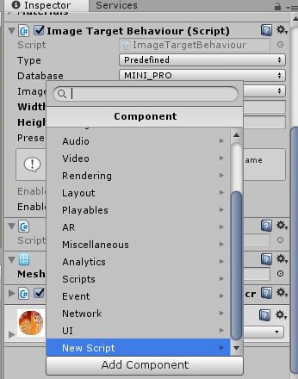  
Fig 7.2.16 Creating and adding a script to virtual button.  
Rename the ‘New Script’ to ‘Action’  
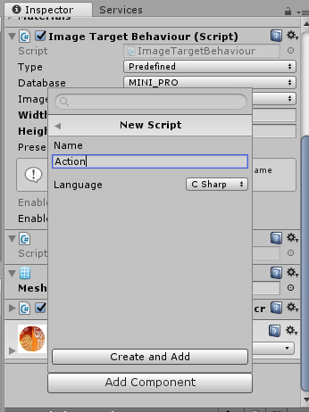  
Fig 7.2.17 click on ‘Create and Add’

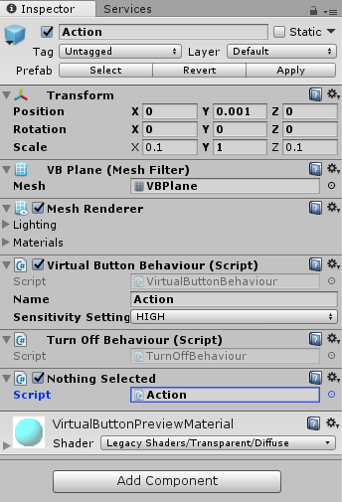  
Fig 7.2.18 Click on ‘Action’ to edit the script in the visual studios.  
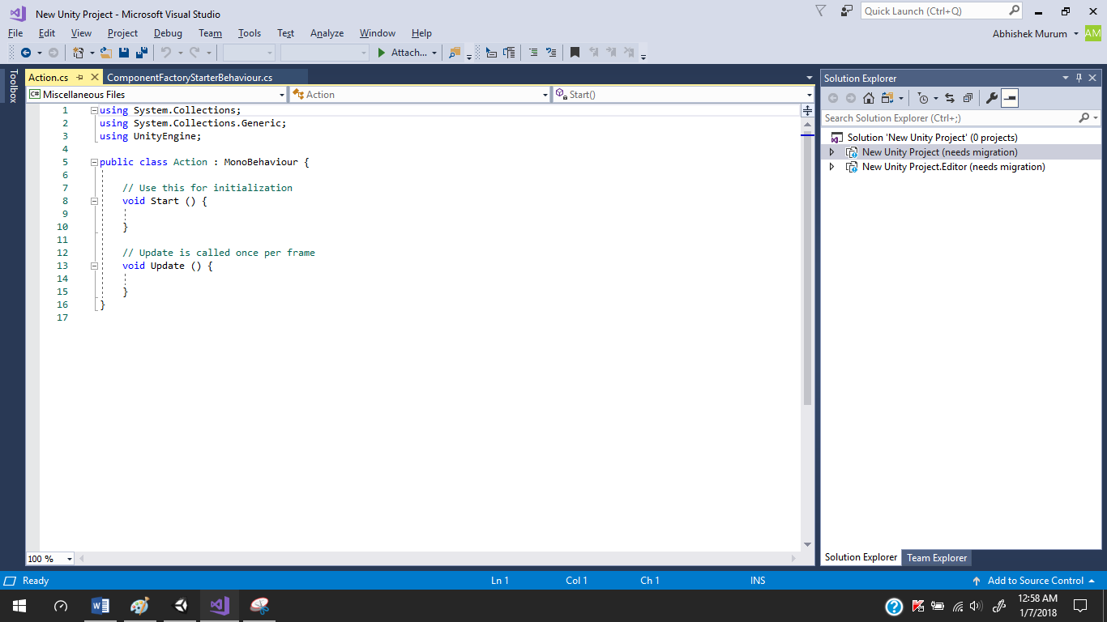

Fig 7.2.19 showing the editing of script in Visual Studios  
Let us define require coding and close the file which will automatically compile the code and reports us the error. The code should be present here is given the ‘CODE’ Section of the Document. Hence Close the studios and edit the virtual button as  
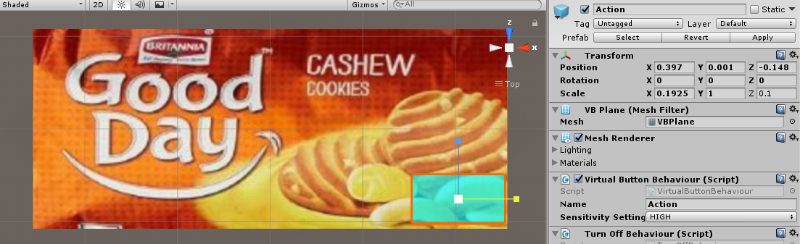

Fig 7.2.20 image showing the positioning of virtual button.  
Then move to the ‘Hierarchy’ Tab.  
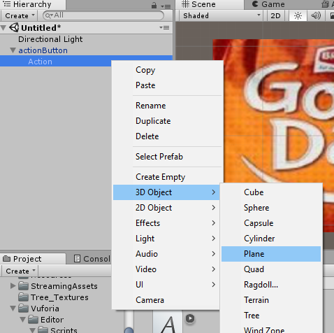  
Fig 7.2.21 illustrating adding a Plane in to our project.  
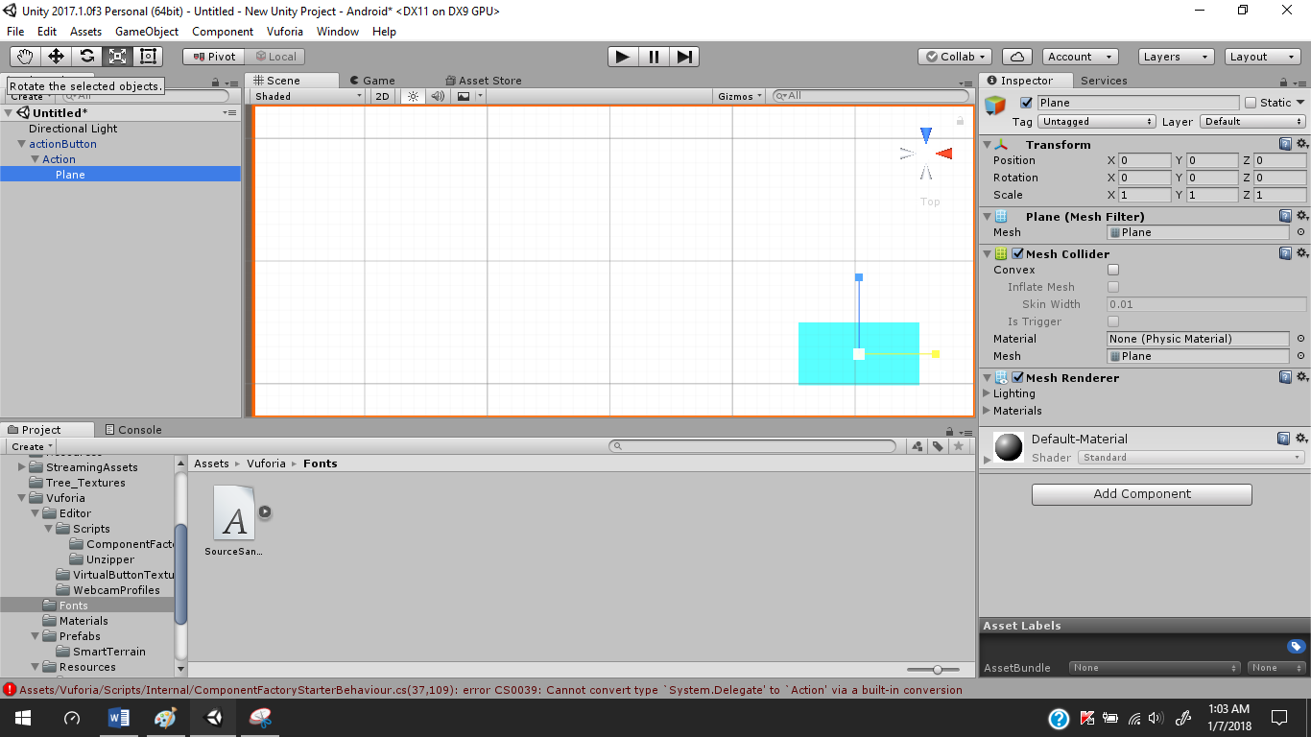

Fig 7.2.21 illustrating adding a Plane in to our project.

edit the plane such that is present over the Virtual Button or Action.  
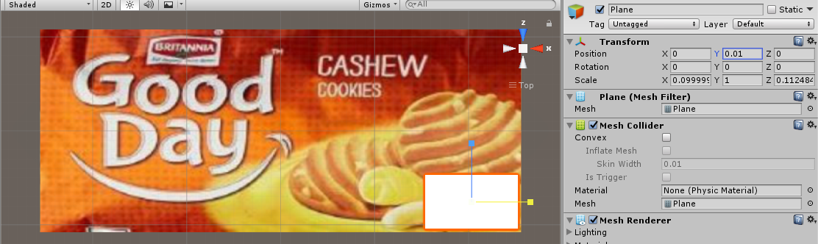  
Fig 7.2.22 positioning plane over button. Now Place Some Text on the Plane/  
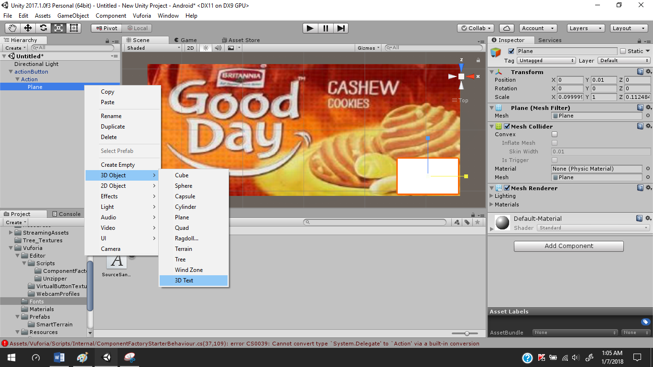

Fig 7.2.23.1 illustrating adding of 3D text on the plane  
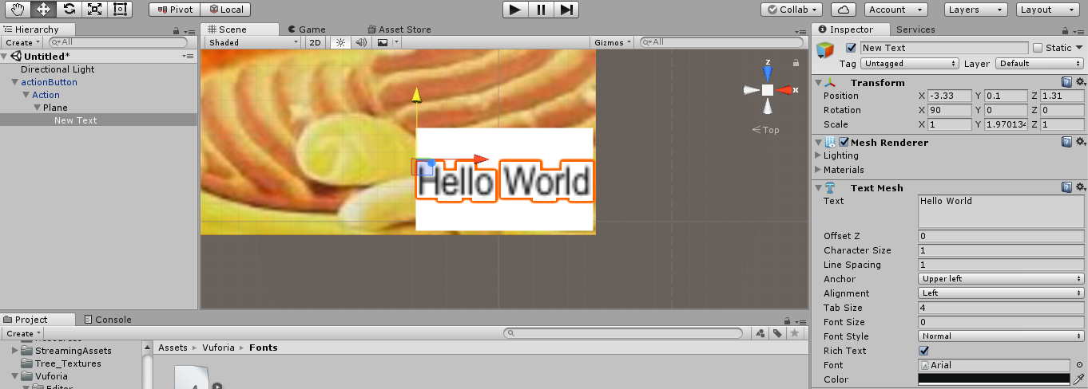  
Fig 7.2.23.1 illustrating positioning of 3D text over the plane  
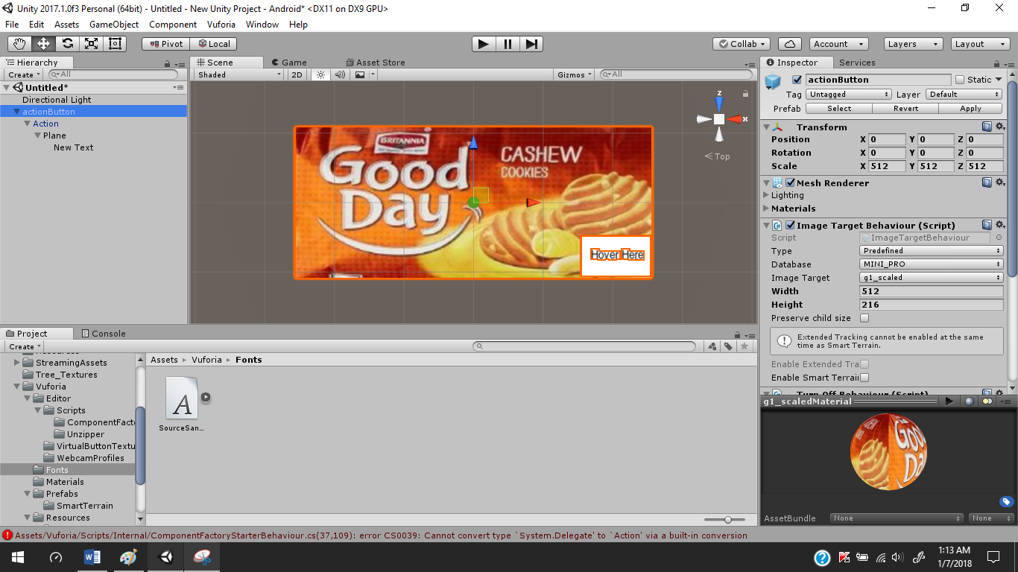  
Fig 7.2.23.2 illustrating positioning of 3D text over the plane  
Click on ‘File’  
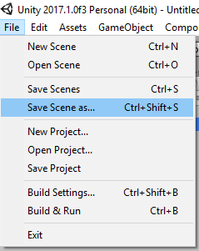  
Fig 7.2.24 Saving the current Scene

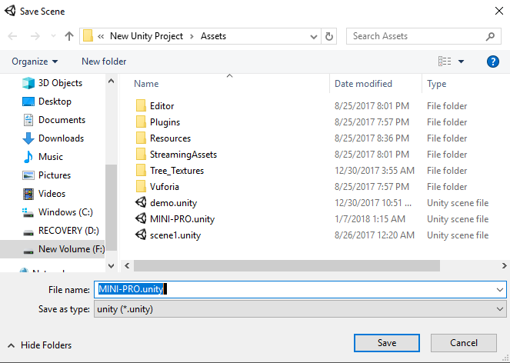  
  
Fig 7.2.25 Saving the scene

**7.3 TRANSFORMING THE UNITY APPLICATION TO ANDROID.**

**Transforming the Unity app to android.**   
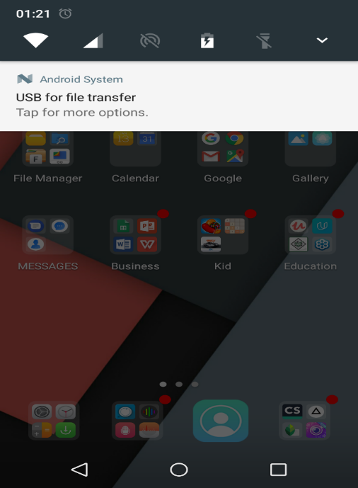  
Fig 7.3.1 Connect the android phone to pc and choose the ‘Transfer Files’ option on your phone  
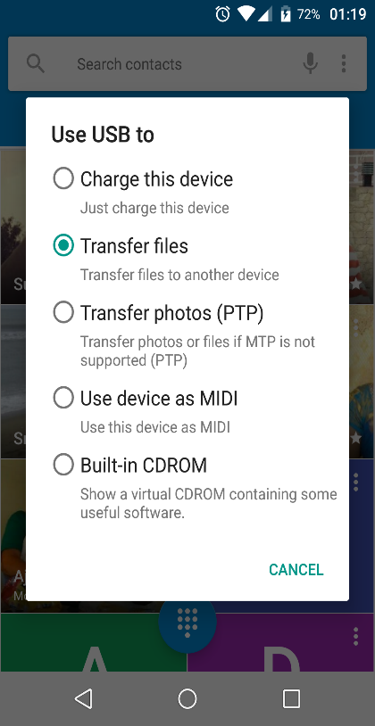  
Fig 7.3.2 showing various option available after enabling developer options  
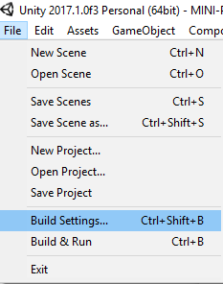  
Fig 7.3.3 go to “File” and select “Build Settings”. This opens   
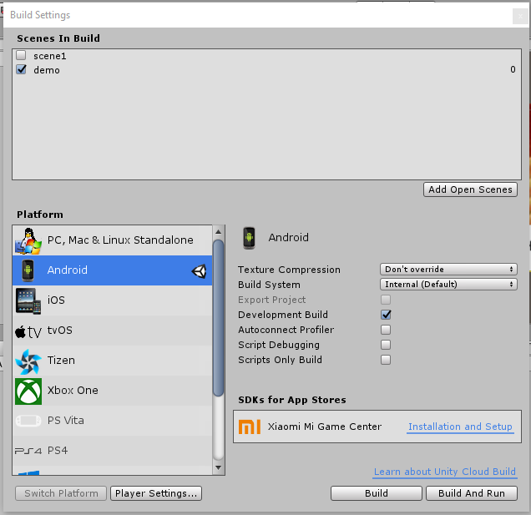  
Fig 7.3.4 Click on the ‘Player Setting’ and move to ‘Inspector’ tab.  
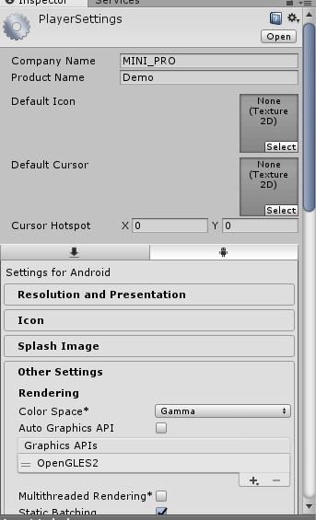  
Fig 7.3.5 Opens Player Settings Tab   
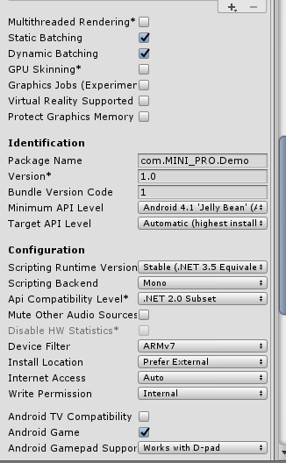  
Fig 7.3.6 Save and build again ,Let the app named as ‘Apps’.Then  
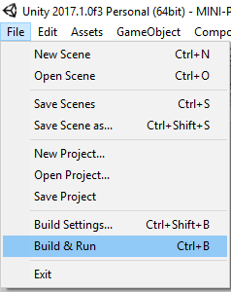  
Fig 7.3.7 Select “Build & Run” to install the app in to our phone.

**7.4: CREATION OF WEB PAGES.**  
   
There are many ways to create a website which is mainly used to show the information as the app scan correct Image Target. Thus the Final output is the web page that is displayed but it first needs to be deployed properly. The code of the webpage can be given in the CODE Section of Document.

**7.5: DEPLOYING OF WEBPAGES.**

Go to XAMPP Installation folder then click on ‘xampp-control.exe’ to show the control panel of xampp.

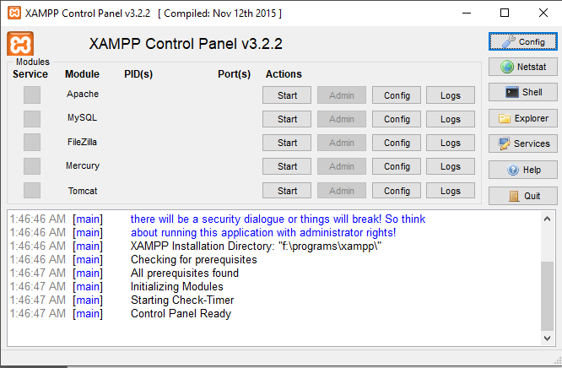  
Fig 7.5.1 Opening XMAPP Control Panel

Then click on ‘Tomcat’ which starts the server we can check the connection port by clicking on ‘config’ and then select’servers.xml’ search for ‘connection-port’. For my system it was 8083. Now open a browser and log on to the server.

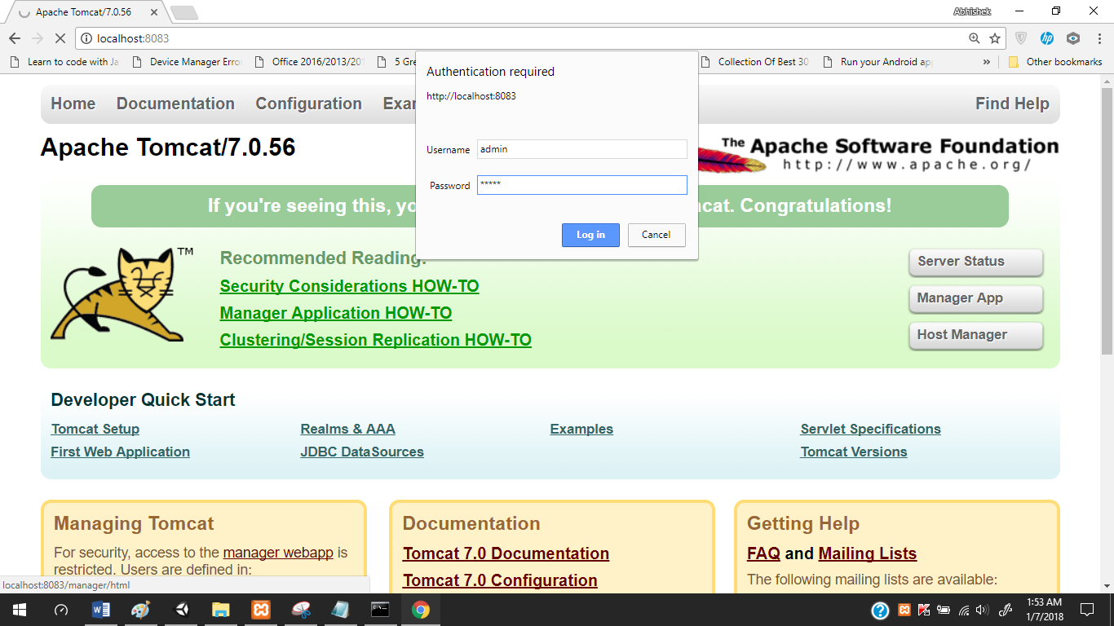  
Fig 7.5.2 Starting and then logging into TOMCAT SERVER, when we login we see  
  
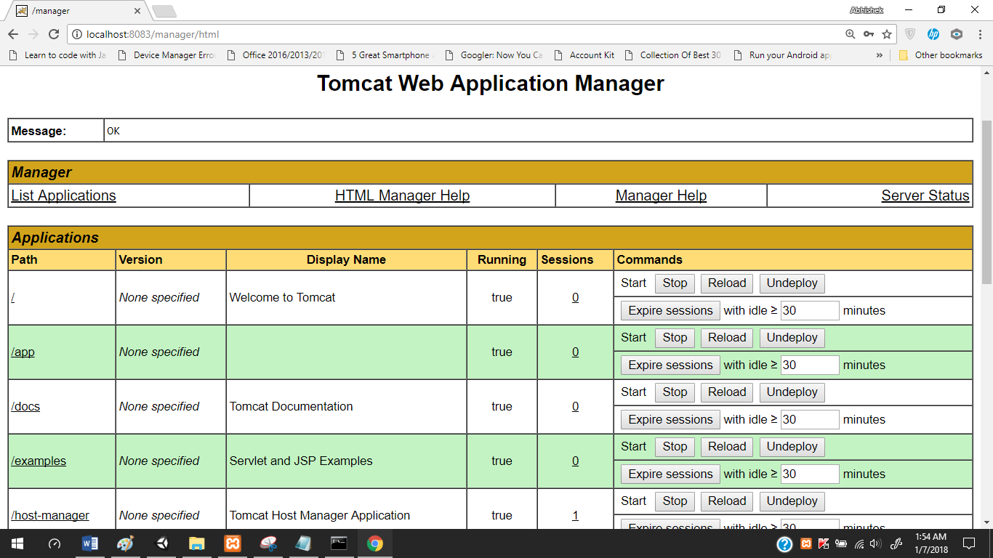

Fig 7.5.3 list of projects are displayed here.

Now let us add the files of our webpages to   
xmapp_installation_folder > tomcat > web-apps > paste the whole website here.  
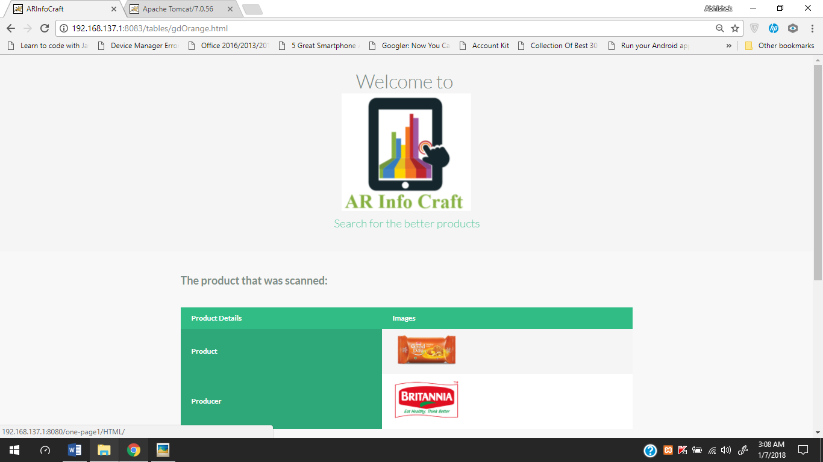

**8 SAMPLE CODE**

**8.1 CODE FOR THE WEBPAGES.**<!DOCTYPE html>

<html lang="en" class="no-js">

<head>

<meta charset="UTF-8" />

<meta http-equiv="X-UA-Compatible" content="IE=edge,chrome=1">

<meta name="viewport" content="width=device-width, initial-scale=1.0">

<title>ARInfoCraft</title>

<meta name="description" content="Sticky Table Headers Revisited: Creating functional and flexible sticky table headers" />

<meta name="keywords" content="Sticky Table Headers Revisited" />

<meta name="author" content="Codrops" />

<link rel="shortcut icon" href="../favicon.ico">

<link rel="stylesheet" type="text/css" href="css/normalize.css" />

<link rel="stylesheet" type="text/css" href="css/demo.css" />

<link rel="stylesheet" type="text/css" href="css/component.css" />

<!--[if IE]>

<script src="http://html5shiv.googlecode.com/svn/trunk/html5.js"></script>

<![endif]-->

</head>

<body style="align-self: center;">

<div class="container">

<header>

<h1>Welcome to <br><a href="http://192.168.137.1:8080/one-page1/HTML/"><img src="logo.png"><span>Search for the better products</span></h1>

</header>

<div class="component">

<h2>The product that was scanned:</h2>

<table>

<thead>

<tr>

<th>Product Details</th>

<th>Images</th>

</tr>

</thead>

<tbody>

<tr>

<th>Product</th>

<td><a href="http://britannia.co.in/products/good-day/butter"><img src="goodday-butter.png" width="150px" /></a></td>

</tr>

<tr>

<th>Producer</th>

<td><a href="http://britannia.co.in/"><img src="britannia-logo.png" width="150px" /></a></td>

</tr>

</tbody>

</table>

<table>

<thead>

<tr>

<th>Final Verdict<br>(Esp.for Diabetes)</th>

<th>Rs 5</th>

<th>Rs 10</th>

<th>Rs 20</th>

</tr>

</thead>

<tbody>

<tr>

<th>Decision for intake</th>

<td><img src="correct.png" width="80px";"></td>

<td><img src="correct.png" width="80px"></td>

<td><img src="correct.png" width="80px"></td>

</tr>

<tr>

<th>Carbohydrates</th>

<td style="text-align: center;">67gm</td>

<td style="text-align: center;">78gm</td>

<td style="text-align: center;">85gm</td>

</tr>

<tr>

<th>Sugars</th>

<td style="text-align: center;">20gm</td>

<td style="text-align: center;">22gm</td>

<td style="text-align: center;">30gm</td>

</tr>

<tr>

<th>Product Weight</th>

<td style="text-align: center;">40gm</td>

<td style="text-align: center;">60gm</td>

<td style="text-align: center;">100gm</td>

</tr>

<tr>

<th>Cholestrol</th>

<td style="text-align: center;">6.5 mg</td>

<td style="text-align: center;">7.8 mg</td>

<td style="text-align: center;">8 mg</td>

</tr>

<tr>

<th>Fats</th>

<td style="text-align: center;">11gm</td>

<td style="text-align: center;">22gm</td>

<td style="text-align: center;">35gm</td>

</tr>

<tr>

<th>Energy</th>

<td style="text-align: center;">494 kCal</td>

<td style="text-align: center;">544 kCal</td>

<td style="text-align: center;">800 kCal</td>

</tr>

</tbody>

</table>

</section>

</div><!-- /container -->

<script src="http://ajax.googleapis.com/ajax/libs/jquery/1/jquery.min.js"></script>

<script src="http://cdnjs.cloudflare.com/ajax/libs/jquery-throttle-debounce/1.1/jquery.ba-throttle-debounce.min.js"></script>

<script src="js/jquery.stickyheader.js"></script>

</body>

</html>

**8.2 Code Used in the Script.**

using System.Collections;

using System.Collections.Generic;

using UnityEngine;

using Vuforia;

public class gdBlue : MonoBehaviour,IVirtualButtonEventHandler {

public GameObject g;

// Use this for initialization

void Start () {

g = GameObject.Find ("actionButton1");

g.GetComponent<VirtualButtonAbstractBehaviour> ().RegisterEventHandler (this);

}

public void OnButtonPressed(VirtualButtonAbstractBehaviour vb)

{

}

public void OnButtonReleased(VirtualButtonAbstractBehaviour vb)

{

Application.OpenURL ("http://192.168.137.1:8080/tables/gdBlue.html");

}

}

**9.OUTPUT SCREEN**

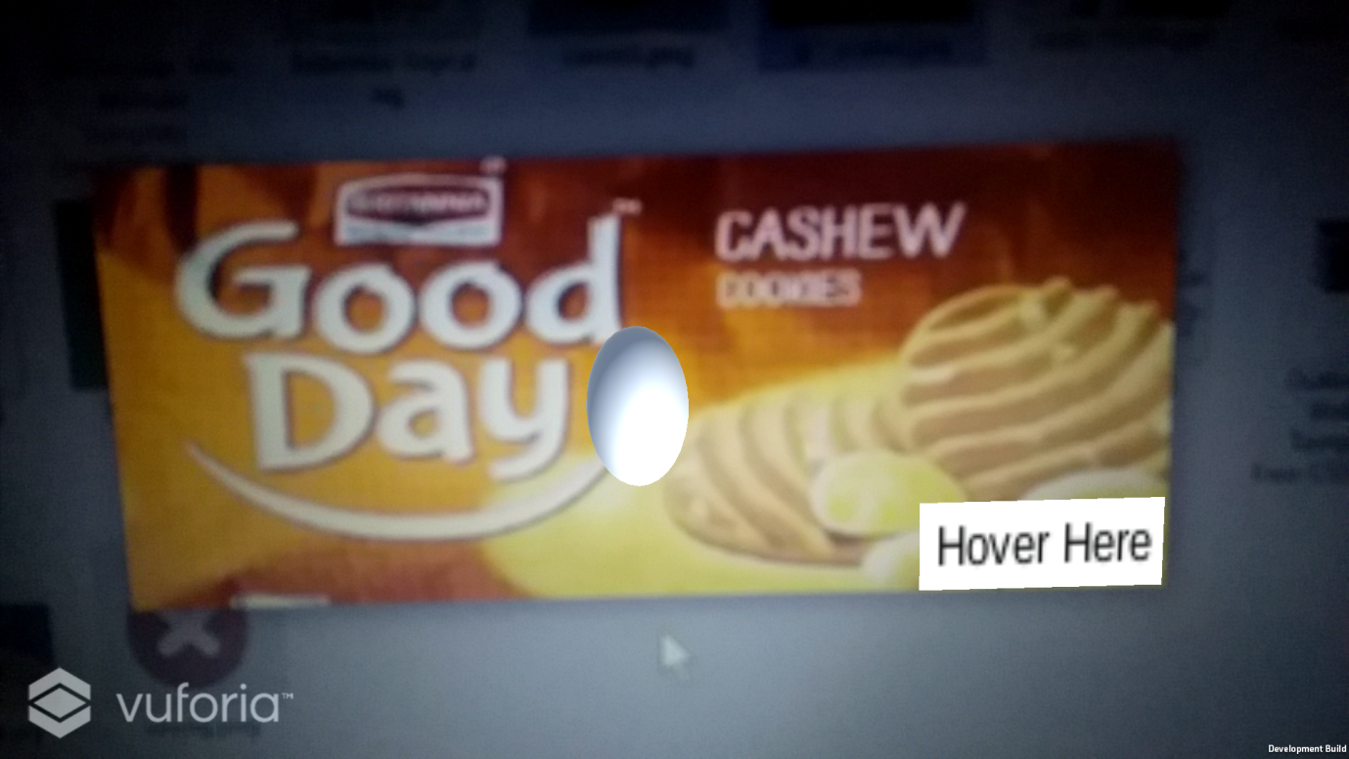

**Fig 9.1- Our app successfully detected a product.**

fdfd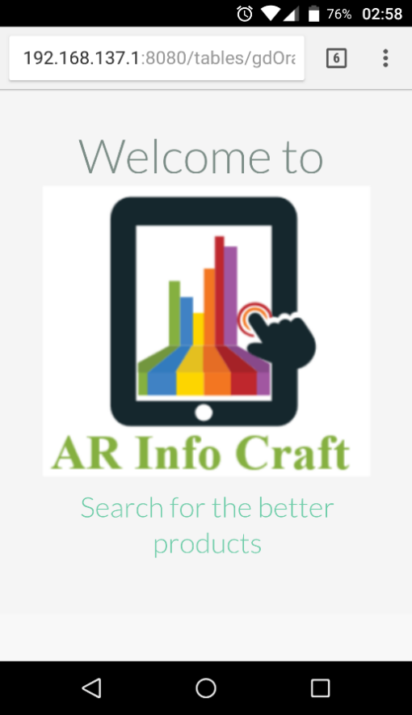

**Fig 9.2 – Displaying the information regarding the product**

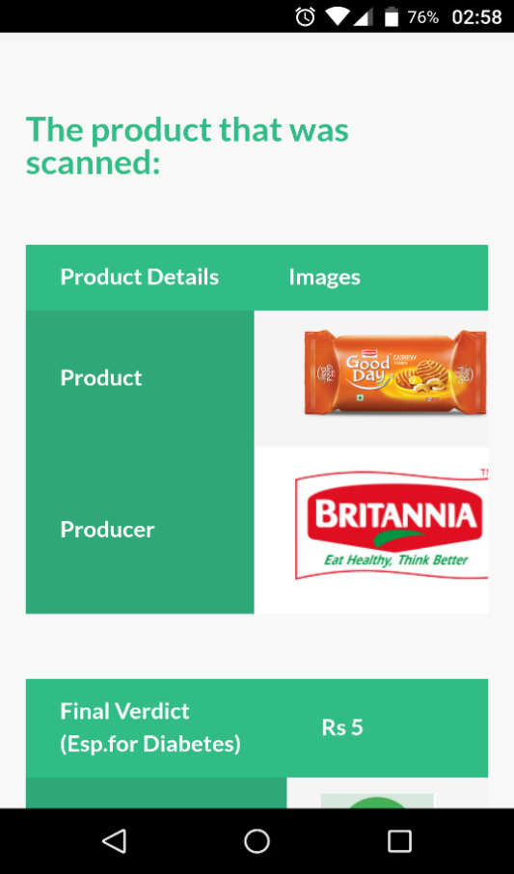

sdsd

**Fig 9.3 – Displaying the Scanned product in web**

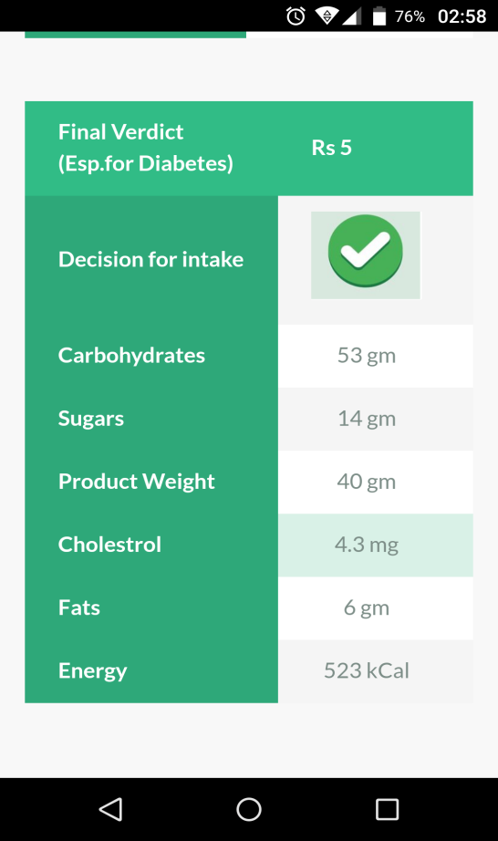

**Fig 9.4 – Validating the product.**

**10. SYSTEM TESTING**

Software testing is a process of executing a program or application with the intent of finding the software bugs. It can also be stated as the process of validating and verifying that a software program or application or product. Meets the business and technical requirements that guided its design and development Works as expected can be implemented with the same characteristic.

**10.1 INTRODUCTION**

Software Testing is the process used to help identify the correctness, completeness, security, and quality of developed computer software. Testing is a process of technical investigation, performed on behalf of stakeholders, that is intended to reveal quality-related information about the product with respect to the context in which it is intended to operate. This includes, but is not limited to, the process of executing a program or application with the intent of finding errors. Quality is not an absolute; it is value to some person. With that in mind, testing can never completely establish the correctness of arbitrary computer software; testing furnishes a criticism or comparison that compares the state and behavior of the product against a specification. An important point is that software testing should be distinguished from the separate discipline of Software Quality Assurance (SQA), which encompasses all business process areas, not just testing.

There are many approaches to software testing, but effective testing of complex products is essentially a process of investigation, not merely a matter of creating and following routine procedure. One definition of testing is "the process of questioning a product in order to evaluate it", where the "questions" are operations the tester attempts to execute with the product, and the product answers with its behavior in reaction to the probing of the tester. Although most of the intellectual processes of testing are nearly identical to that of review or inspection, the word testing is connoted to mean the dynamic analysis of the product—putting the product through its paces. Some of the common quality attributes include capability, reliability, efficiency, portability, maintainability, compatibility and usability. A good test is sometimes described as one which reveals an error; however, more recent thinking suggests that a good test is one which reveals information of interest to someone who matters within the project commands.

**10.2 TESTING METHODOLOGY**

**10.2.1 Unit testing**

Unit testing involves the design of test cases that validate that the internal program logic is functioning properly, and that program inputs produce valid outputs. All decision branches and internal code flow should be validated. It is he testing of individual software units of the application. It is done after the completion of individual unit before integration. This is a structural testing, that relies on knowledge of its construction and is invasive. Unit tests perform basic tests at component level and test a specific business process, application, and/or system configuration. Unit tests ensure that each unique path of a business process performs accurately to the documented specifications and contains clearly defined inputs and expected results.

**10.2.2 Integration testing**

Integration tests are designed to test integrated software components to determine if they actually run a one program. Testing is event driven and is more concerned with the basic outcome of screens or fields. Integration tests demonstrate that although the components were individually satisfied, as shown by successful unit testing, the combination of components is correct and consistent. Integration testing is specifically aimed at exposing the problems that arise from the combination of components.

**10.2.3 Functional test**

Functional testing verifies that each function of the software application operates in conformance with the requirement specification. This testing mainly involves black box testing and it is not concerned about the source code of the application. Each functionality of the system is tested by providing appropriate input, verifying the output and comparing the actual results with the expected results. This testing involves checking of User Interface, APIs, Database, security, client/ server applications and functionality of the Application under Test. The testing can be done either manually or using automation.

**10.2.3.1 Functional Testing Process:**

* + Understand the requirements
  + Identify test inputs
  + Compute the expected outcomes with the selected test input values
  + Execute test cases
  + Comparison of computed and expected result.

**10.2.3.2 System testing**

System testing is actually a series of different tests whose sole purpose is to exercise the full computer based system. System testing falls under the black box testing category of software testing. White box testing is the testing of the internal workings or code of a software application. In contrast, black box or system testing is the opposite. System testing involves the external workings of the software from the user's perspective.

System testing involves testing the software code for the following:

* Testing the fully integrated applications including external peripherals in order to check how components interact with one another and with the system as a whole. This is also called End to End scenario testing.
* Verify thorough testing of every input in the application to check for desired outputs.
* Testing of the user's experience with the application.

**10.2.4 BLACK BOX TESTING:**

Black-box testing (also known as functional testing) treats software under test as a black-box without knowing its internals. Tests are using software interfaces and trying to ensure that they work as expected. As long as functionality of interfaces remains unchanged, tests should pass even if internals are changed. Tester is aware of what the program should do but does not have the knowledge of how it does it. Black-box testing is most commonly used type of testing in traditional organizations that have testers as a separate department, especially when they are not proficient in coding and have difficulties to understand the code. It provides external perspective of the software under test.

Some of the advantages of black-box testing are:

* 1. Efficient for large segments of code
  2. Code access is not required
  3. Separation between user’s and developer’s perspectives

**10.2.5 WHITE BOX TESTING**

White-box testing (also known as clear box testing, glass box testing, and transparent box testing and structural testing) looks inside the software that is being tested and uses that knowledge as part of the testing process. If, for example, exception is thrown under certain conditions, test might want to reproduce those conditions. White-box testing requires internal knowledge of the system and programming skills. It provides internal perspective of the software under test.

Some of the advantages of white-box testing are:

1. Efficient in finding errors and problems
2. Required knowledge of internals of the software under test is beneficial for through testing
3. Allows finding hidden errors
4. Programmers introspection
5. Helps optimizing the code
6. Due to required internal knowledge of the software, maximum coverage is obtained.

**10.2.6 Level of Testing**

Unit Testing

* Integration Testing
* Component Testing
* System Testing
* User Acceptance Testing

**10.2.7 Types of Testing**

* + Smoke Testing
  + Sanitary Testing
  + Regression Testing
  + Re-Testing
  + Static Testing
  + Dynamic Testing
  + Alpha-Testing
  + Monkey Testing
  + Beta-Testing
  + Compatibility Testing
  + Installation Testing
  + Adhoc Testing

**10.2.8 TEST CASE DOCUMENT CONTAINS:**

* **Test Scope (or) Test Objective**

Test coverage is provided for the screen “Academic status entry” form of a student module of university management system application.

* **Test Scenario**

When the office personals use this screen for the marks entry, calculate the status details, saving the information on student’s basis and quit the form.

* **Test Procedure**

The procedure for testing this screen is planned in such a way that the data entry, status calculation functionality, saving and quitting operations are tested in terms of GUI testing, Positive testing, Negative testing using the corresponding GUI test cases, Positive test cases, Negative test cases respectively.

**10.2.9 TEST CASES**

**Loading AR Camera**

|  |
| --- |
| **Test Case 3: Loading AR Camera** |
| **Test Objective:** To check whether the camera is loaded on Click on button |
| **Test Description:** The user should HOVER on LoadAR button to load AR Camera. |
| **Requirements Verified :** Yes |
| **Test Environment:** Test Environment includes Unity Editor and mobile running on  Android Operating system. |
| **Test Setup/Pre-Conditions:** Mobile App should be working properly. |
| **Actions Expected results**  The user clicks the ‘LoadAR’ button. AR Camera is Loaded. |
| **Pass** : Yes **Condition Pass**: yes **Fail** : No |
| **Problems / Issues**: NIL |
| **Note**: Successfully Executed. |

**Table 10.9.1 –Test Case for Loading AR Camera.**

**3D Model Augment Test**

|  |
| --- |
| **Test Case 4:** 3D Model Augment Test |
| **Test Objective:** To check whether the 3D Model is augmented on Target Image or not. |
| **Test Description:** The AR Camera scene is opened and Target Image is Scanned. |
| **Requirements Verified :** Yes |
| **Test Environment:** Test Environment includes Unity Editor and mobile running on  Android Operating system. |
| **Test Setup/Preconditions:** Mobile App should be working properly. |
| **Actions Expected results**  Pan the Camera over the Target Image. 3D model is Augmented over the Target Image. |
| **Pass** : Yes **Condition Pass**: yes **Fail** : No |
| **Problems / Issues**: NIL |
| **Note**: Successfully Executed. |

**Table 10.9.2 –Test Case for 3D Model Augmented Test.**

**11.CONCLUSION AND FUTHUR ENHANCEMENTS**

**11.1 CONCLUSION:**

The “ARINFOCRAFT” was successfully designed and is tested for accuracy and quality. The entire project has been developed and deployed as per the requirements stated by the user. It is found to be bug free as per the testing standards that are implemented. We believe ARINFOCRAFT will be game changer in the market where people would love to use our services.

**11.2 FUTURE WORK**

As of now we have developed the ARINFOCRAFT as a small prototype. In near future we will come up with a finished product. We would also like to extend the features of this ARINFOCRAFT

**12.ONLINE REFERENCE’S:**

ANDROID SDK: <https://developer.android.com/studio/index.html>

DIABETES CANADA: <http://www.diabetes.ca/about-diabetes/types-of-diabetes>

JAVA SDK: <http://www.oracle.com/technetwork/java/javase/downloads/jdk8-downloads-2133151.html>

UNITY-REQUIREMENTS: <https://unity3d.com/unity/system-requirements>

UNITY-INSTALLATION- <https://store.unity.com/download?ref=personal>

VUFORIA: <https://developer.vuforia.com/>

WAMP: <http://www.wampserver.com/en/>

XAMPP: <https://www.apachefriends.org/index.html>